Full Stack Java Developer



July

2022

Phase-6: Capstone Project

* **Project**: FOODBOX
* **Developer**: JANMEJAY YADAV

# Project and Developer Details

This project aims to design and develop an E-commerce website that lets people shop food items of different cuisines at affordable prices and deliver the products to their addresses. It was developed using Angular and Spring boot It was created as the Capstone Project for the Full Stack Java Developer course.

Sprints and Tasks.

Product Backlog:

**Programming**:

1. Create database and tables.
2. Add some rows and metadata to the tables 3. Initialize a Spring Boot project for the Back-End side.
3. Create REST APIs with spring Data JPA Repositories.
4. Create desired DAO methods for the Back-End side
5. Create a new Angular project for the Front-End side.
6. Create login and register pages and components.
7. Add cache to the login user
8. Logout user and remove cache 10. Show all products to the home page.
9. Show all products as cards.
10. Create a product details component.
11. Search a product by a category.
12. Search a product by a keyword.
13. Add products pages
14. Filter by page number
15. Sort product by different options 18. Add products to the cart.
16. Update total price in the cart status.
17. Show the payment gate and review the list
18. Add and remove products from the review list
19. Update the total price in the payment gate
20. Create the admin view
21. Update/Remove a product for the admin
22. Add a new product for the admin
23. Update the CSS design
24. Add bootstrap and font awesome to the components.
25. Debug and test the project.

**Deployment**:

1. Upload project to GitHub.
2. Create a t3.medium instance for master.
3. Create a t3.micro instance for slave.
4. Connect the two instances to the system
5. Create a Pipeline project on Jenkins.
6. Create a Jenkins file.
7. Generate a SSH key for GitHub.
8. Build the pipeline project.
9. Deploy the project.

|  |  |  |  |
| --- | --- | --- | --- |
| **Sprints** |  | **Tasks** | **Days** |
| Sprint 1 | o o o o o | Create database and tables.  Add some rows and metadata to the tables  Initialize a Spring Boot project for the Back-End side. Create REST APIs with spring Data JPA Repositories.  Create desired DAO methods for the Back-End side | 1 day |
| Sprint 2 | o o o o | Create a new Angular project for the Front-End side.  Create login and register pages and components.  Add cache to the login user  Logout user and remove cache | 1 day |
| Sprint 3 | o o o o o | Show all products to the home page. Show all products as cards.  Create a product details component.  Search a product by a category. Search a product by a keyword. | 1 day |
| Sprint 4 | o o o o o | Add products pages  Filter by page number  Sort product by different options Add products to the cart.  Update total price in the cart status. | 1 day |
| Sprint 5 | o o o | Show the payment gate and review the list  Add and remove products from the review list  Update the total price in the payment gate | 1 day |
| Sprint 6 | o o o | Create the admin view  Update/Remove a product for the admin  Add a new product for the admin | 1 day |
| Sprint 7 | o o o | Update the CSS design  Add bootstrap and font awesome to the components.  Debug and test the project. | 1 day |
| Sprint 8 | o o o o o | Upload project to GitHub.  Create a t3.medium instance for master.  Create a t3.micro instance for slave. Connect the two instances to the system Create a Pipeline project on Jenkins. | 1 day |
|  | o | Create a Jenkins file. |  |
|  | o | Generate a SSH key for GitHub. |  |
| Sprint 9 | o o o | Build the pipeline project.  Debug problems  Deploy the project. | 1 day |

# Technologies and tools Used

* **Angular:** used in the front-end sideto build modern single-page applications
* **Spring Boot:** used in the back-end sideto create the REST API and retrieve data from a database. • **AWS EC2 instance:** to use the instances as a VM and deploy the application
* **AWS RDS:** to upload the database online.
* **Jenkins:** to build the project from GitHub.
* **GitHub**: to upload the source code of the project.
* **MobaXterm**: to the instance from Windows OS.
* **Selenium:** for automation and testing.
* **Apache**: to use it as a web server.
* **HTML/CSS**: to create and format the content of the pages.
* **Bootstrap**: to use some CSS and JavaScript designs.
* **Maven**: to manage the project.
* **Visual Studio Code**: to write and run the Angular code.
* **IntelliJ**: to write and run the Spring Boot code.
* **MySQL**: to use it as database management system.
* **phpMyAdmin**: to administrate and manage the database manually.

# Flowcharts of The Application

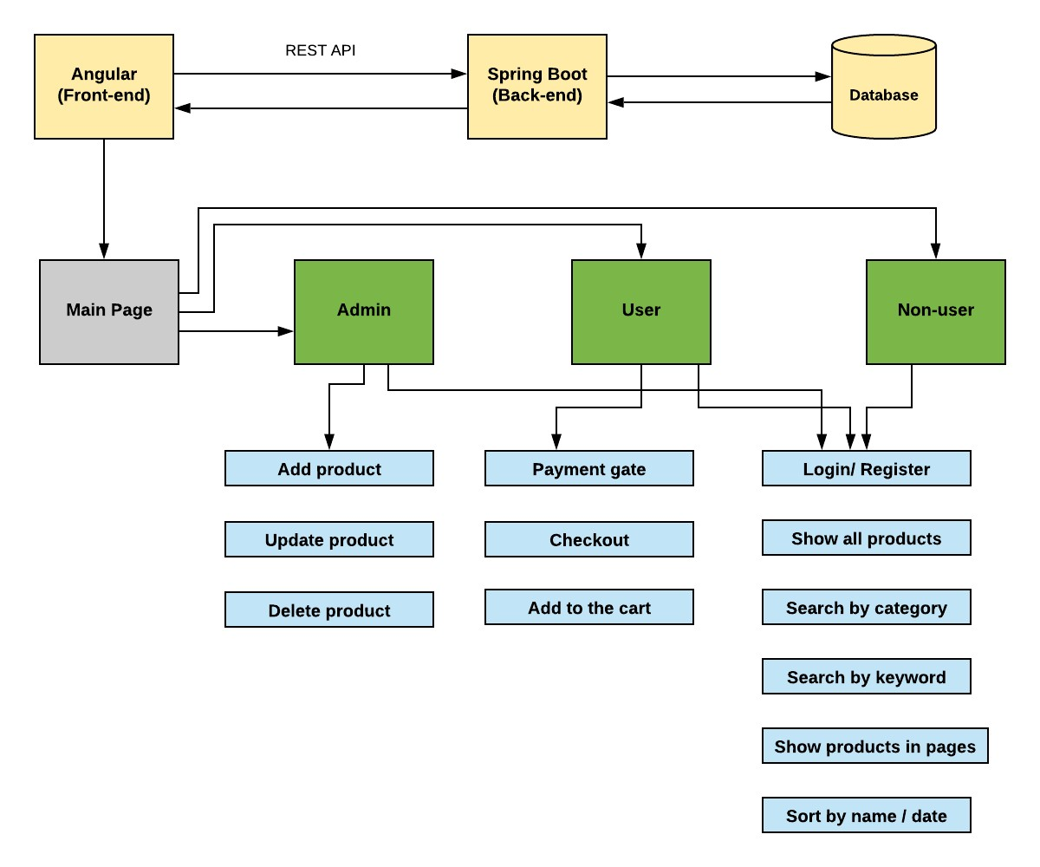

Core concepts used in the project.

* **Object-Oriented**: used to create and model objects for users and their credentials.
* **REST API**: used to communicate between the back-end and the front-end sides.
* **Data Access Object**: to abstract and encapsulate all access to the data source.
* **Object–Relational** **Mapping**: to map the objects to the database.
* **Databases:** used to store and retrieve data.
* **Data Sources**: used to define a set of properties required to identify and access the database.
* **Collections**: used some collections such Arraylist to store collection of data.
* **Deployment:** to deploy the local project to the end-users.
* **Virtual Machine**: use virtual instances to help to build, deploy and manage websites.
* **Exception Handling**: used to catch problems that arises in the code especially in I/O blocks.
* **Single Web Page**: apply the concept of a website that only contains one HTML page.

GitHub Repository

https://github.com/janmejayy/FoodBox_WebApplication.git

# How to run the program locally

* clone project o clone git : git clone https://github.com/janmejayy/FoodBox_WebApplication.git

* Import the “\Back-End\foodbox\database\foodbox.sql” file to your database administration tool.
* Go to “\Back-End\foodbox\src\main\resources\application.properties” file, open it.
* Edit some values of the database’ properties to be suit to your database administration tool.
* Run the back-end project as a maven project: o *cd to your project “Back-end\foodbox”* 
  + *mvn compile*
  + *mvn exec:java -Dexec.mainClass=com.simplilearn.foodbox*
* Open another command line for the front-end part. • cd to your project “Front-end-end\foodbox”
* install the following:
  + *npm install --save-dev* o *npm install @angular/localize --save* o *npm install bootstrap --save* o *npm install font-awesome –save*
* Run using *ng serve –open*
* *It would be displayed in* [*http://localhost:4200/*](http://localhost:4200/)

# Screenshots

* General look of the store:

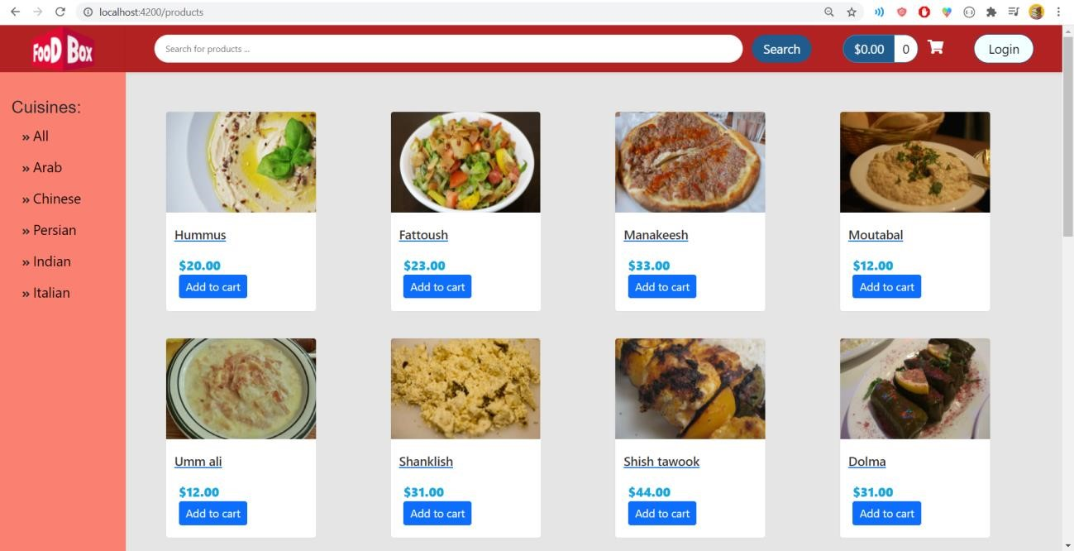

Filter the product according to the cuisine

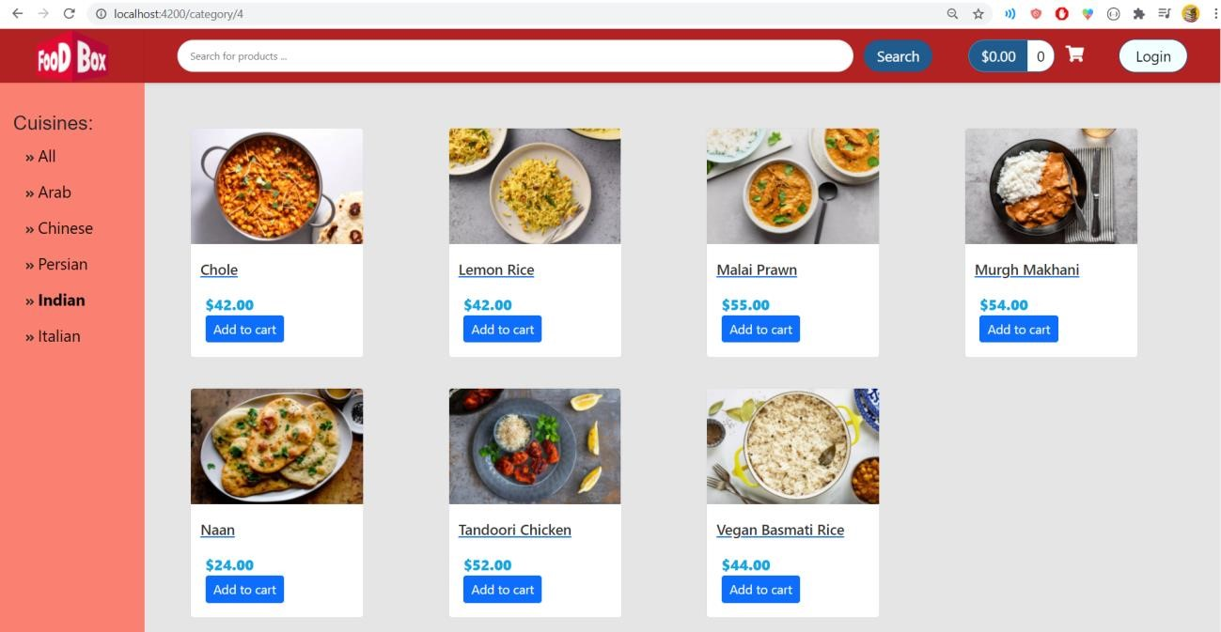

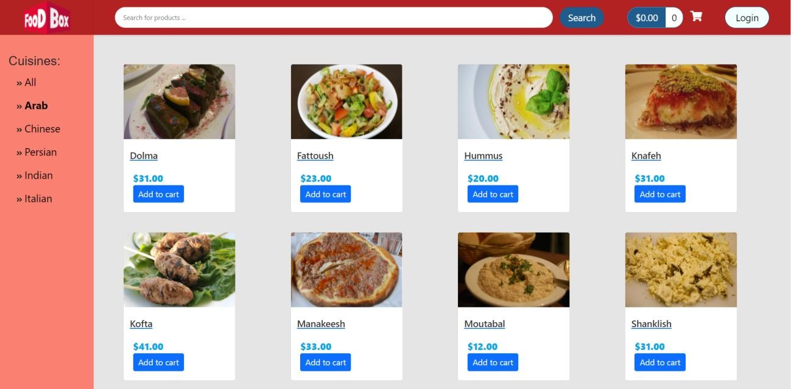

Filtering by page and sorting are available

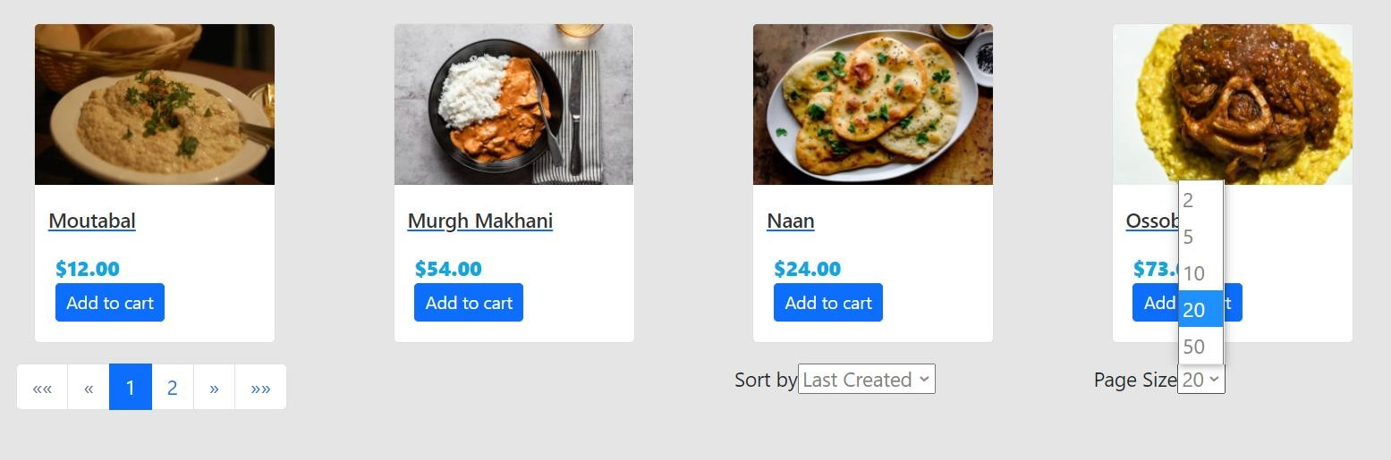

* Sorting can be in one of these three options

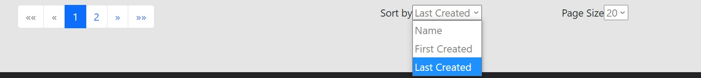

* Sorting by name

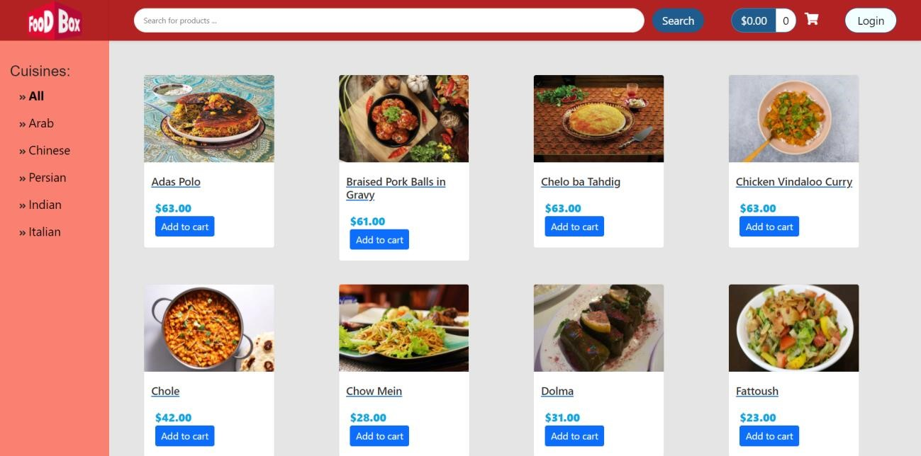

Choosing the number of each displayed products in each page

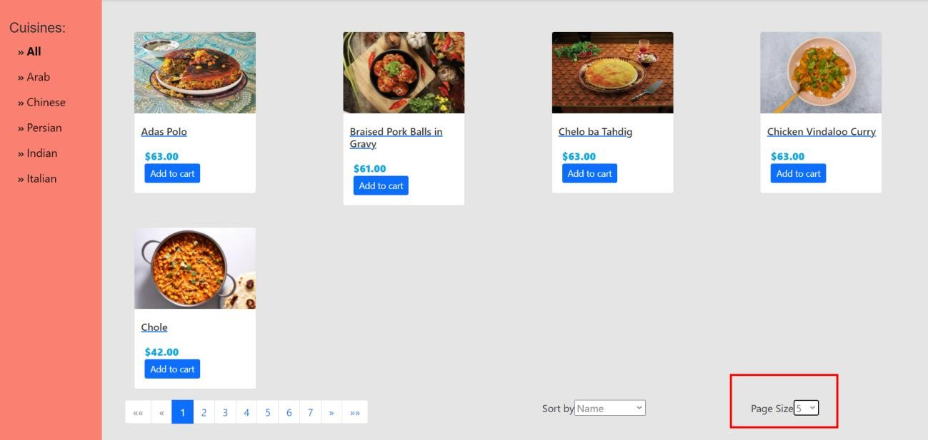

* You can add products to the cart

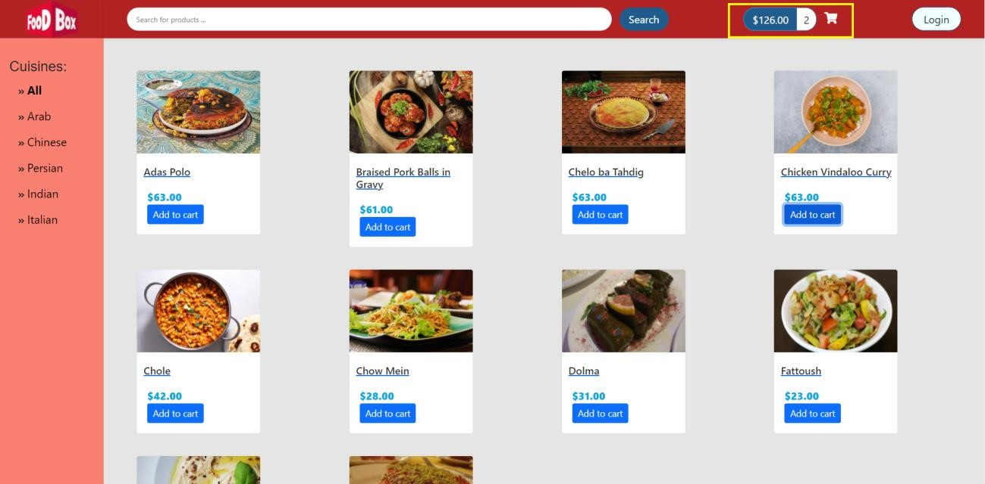

However, you need to be registered to buy

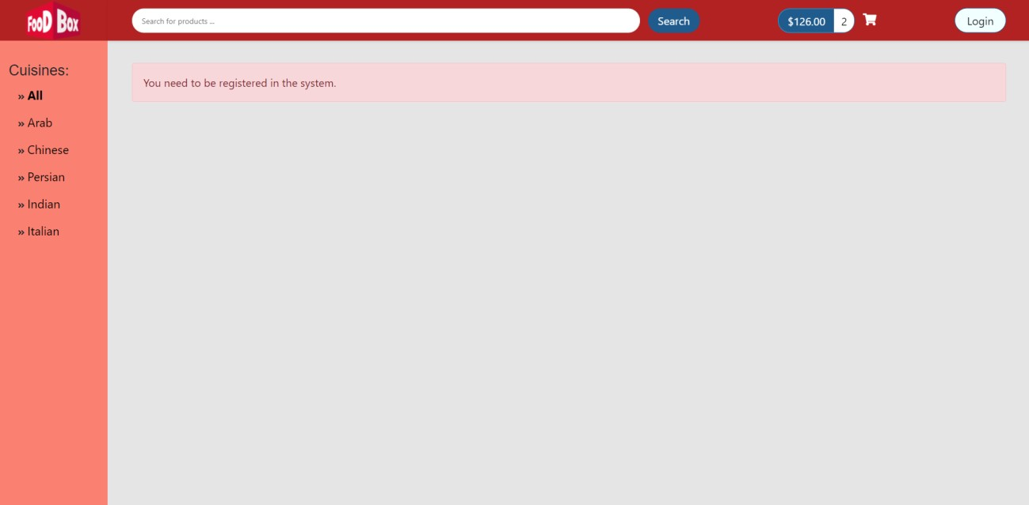

* Login and then create account

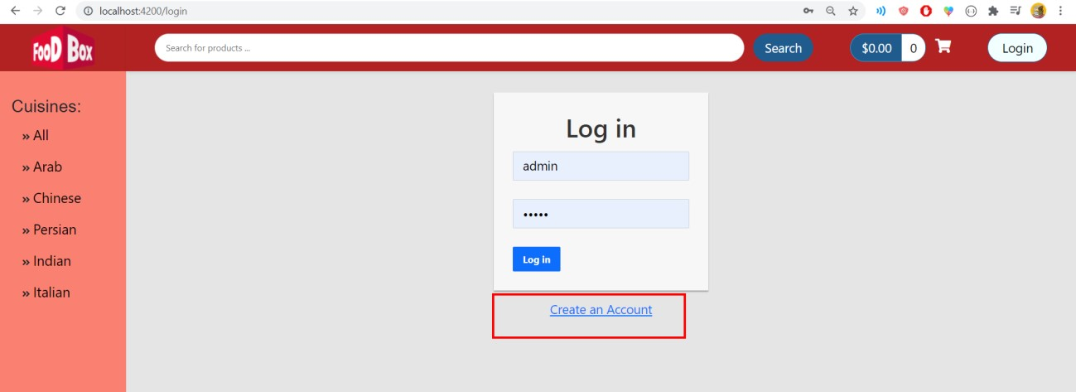

Register form

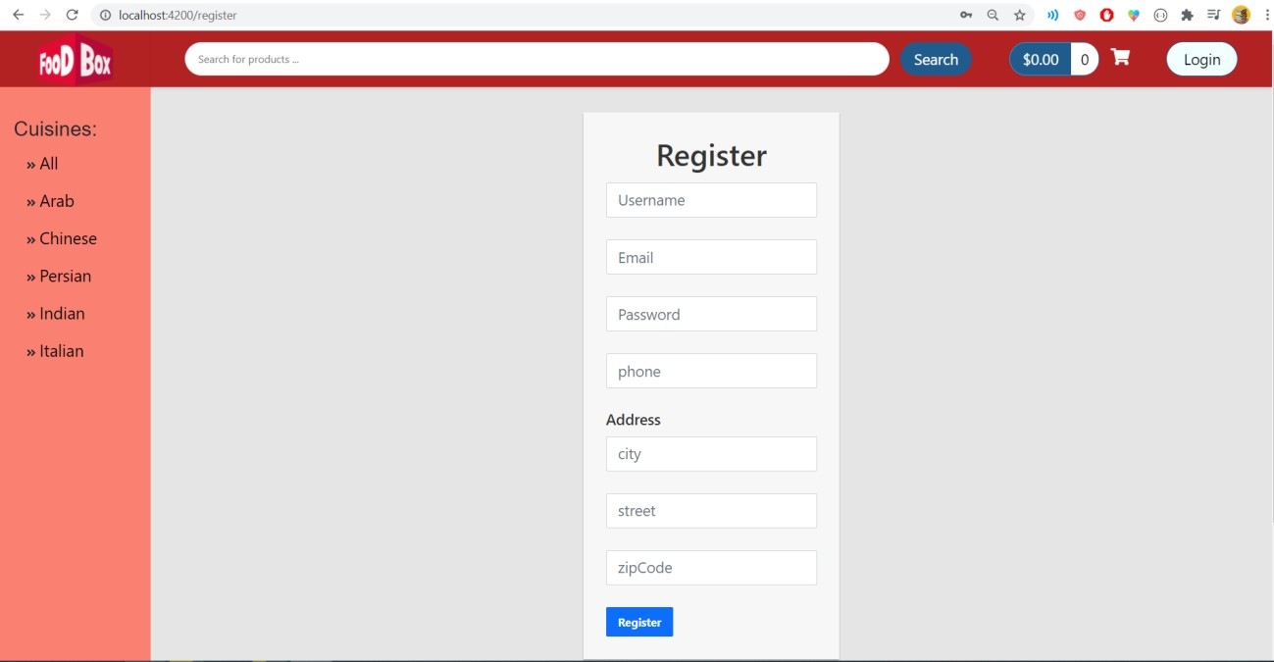

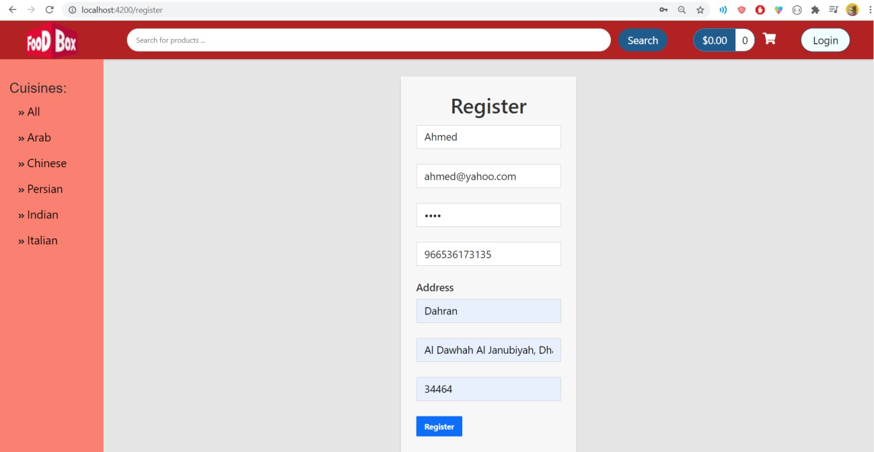

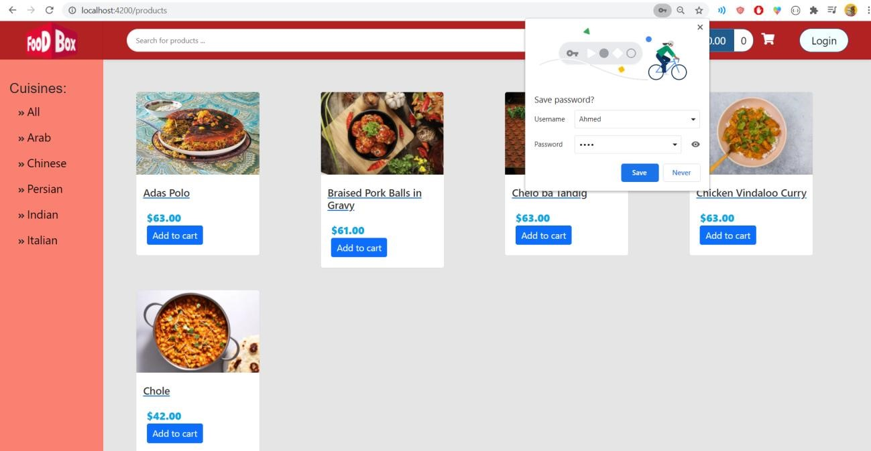

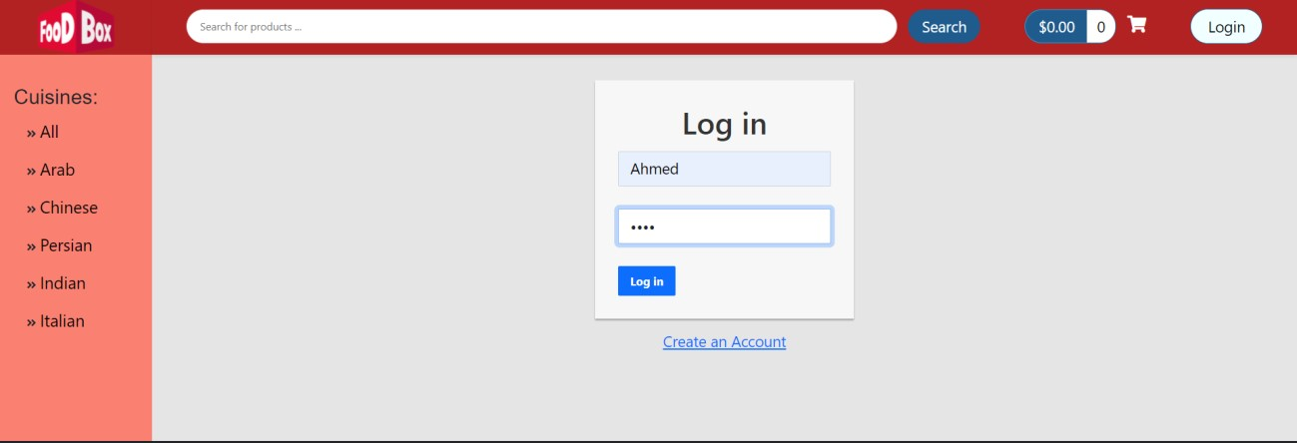

User logined

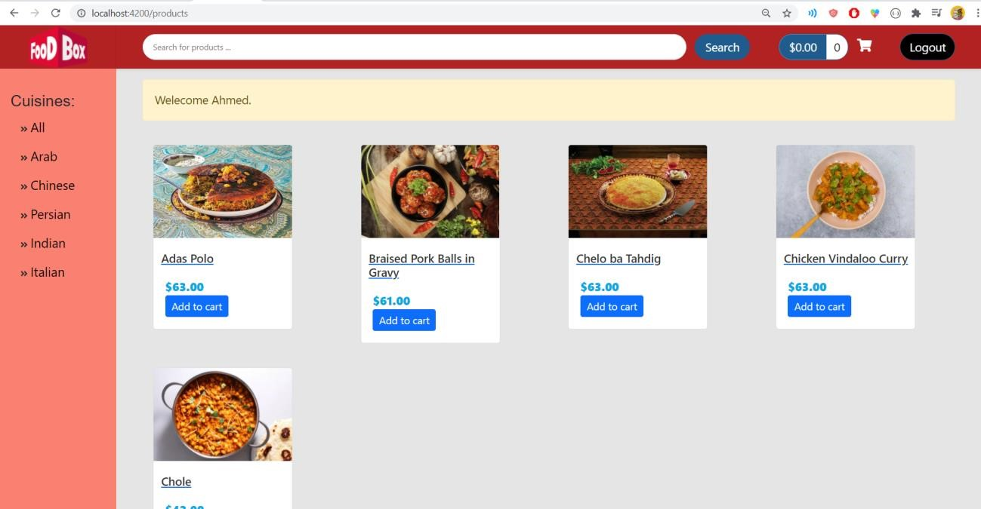

* User can now buy (Payment gateway)

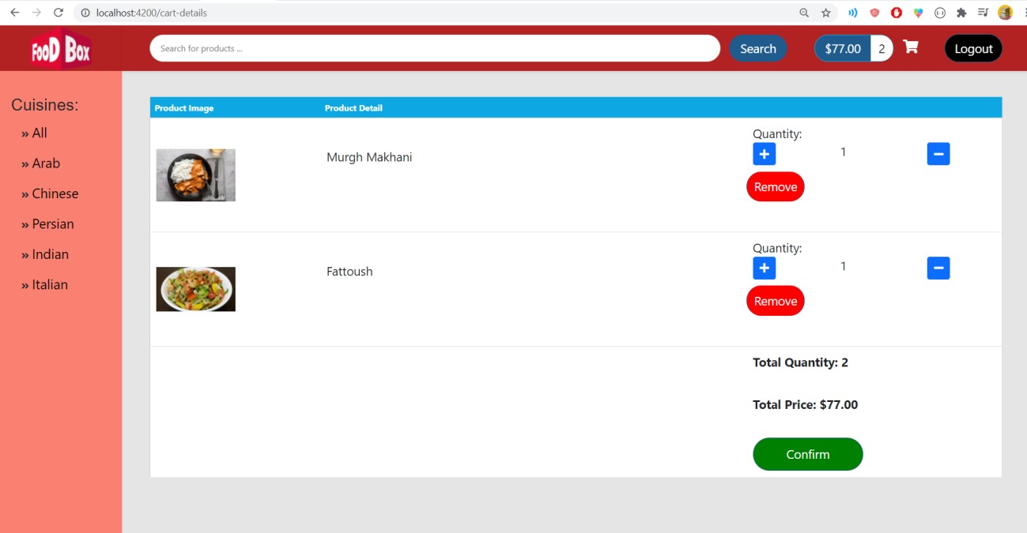

Can add/remove products during review

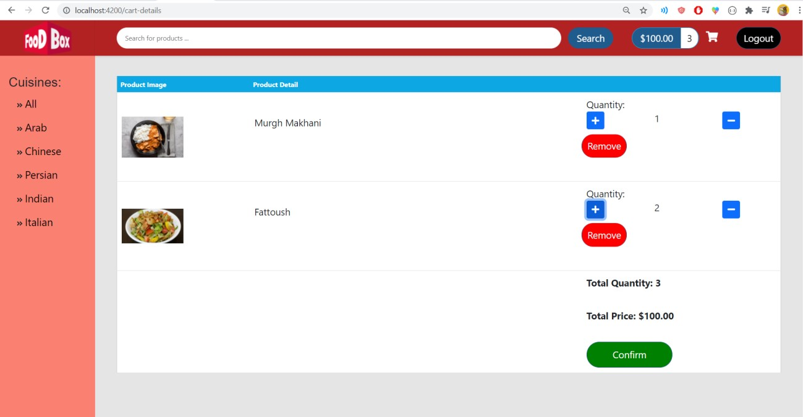

* Check-out and confirm

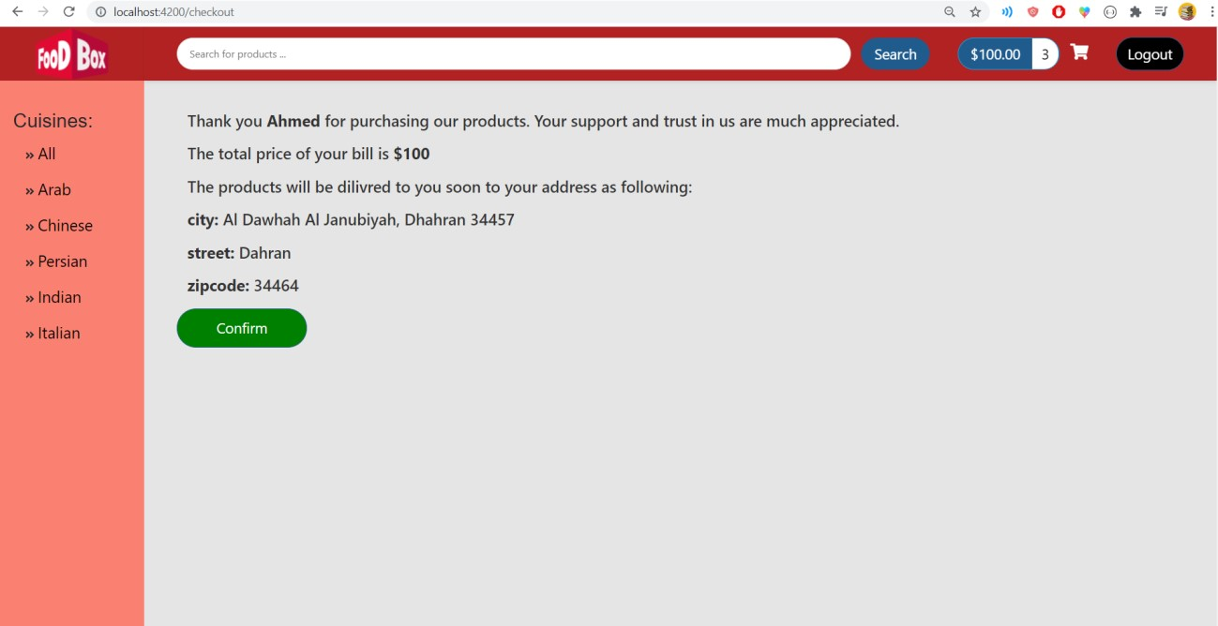

Search products by Name

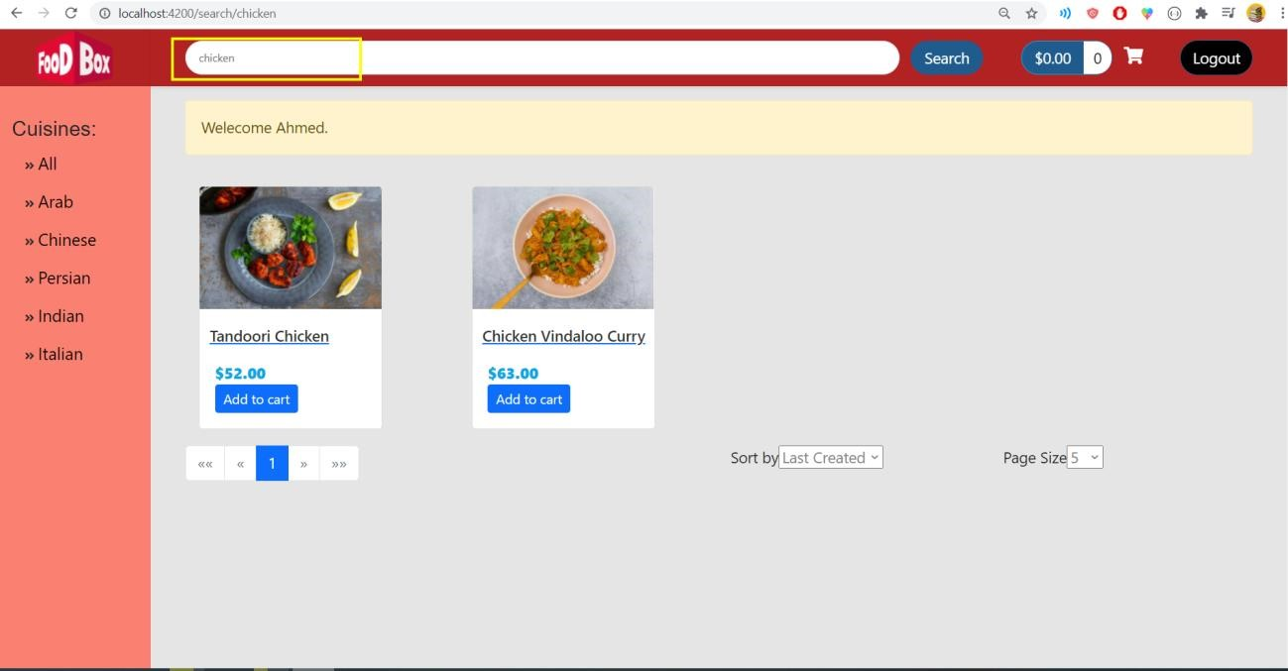

* Now, let’s log in as admin
* Admin/admin

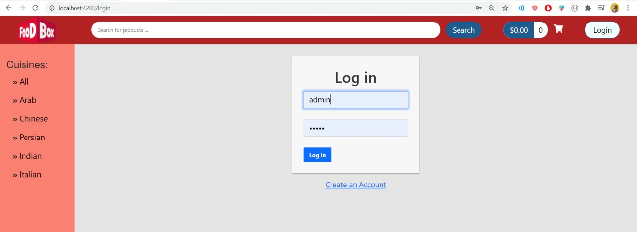

Admin can:

o Create product o Edit product o Delete product

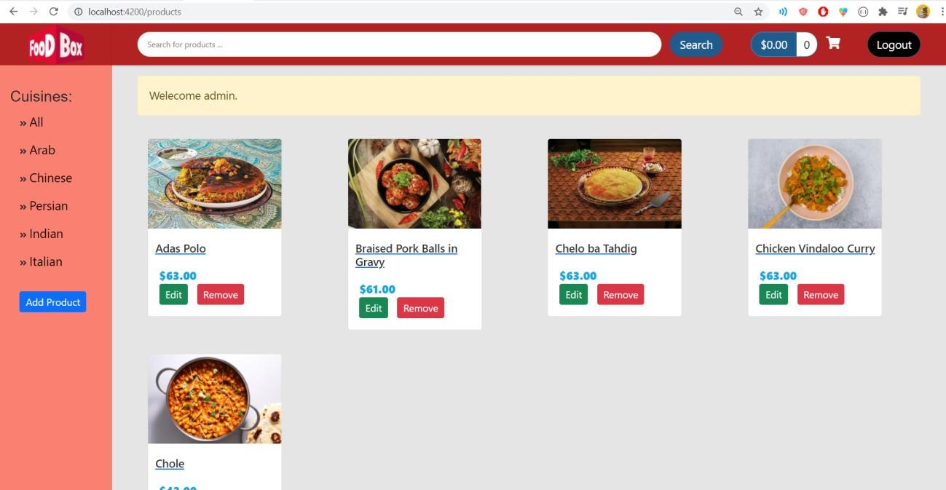

* Create a new product

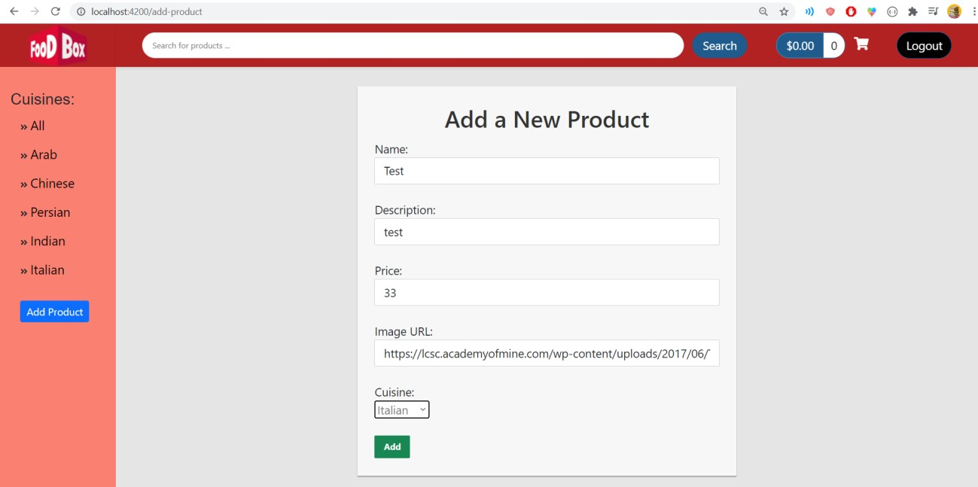

The new product was added

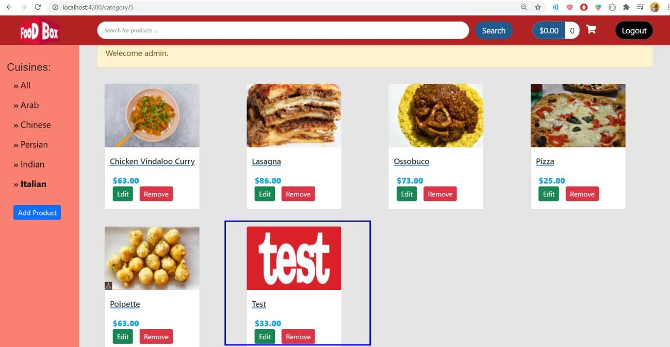

* Let’s update it

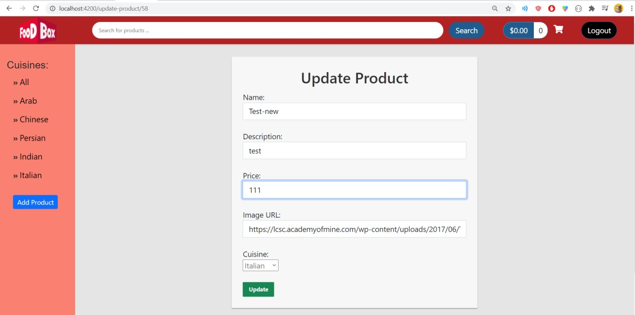

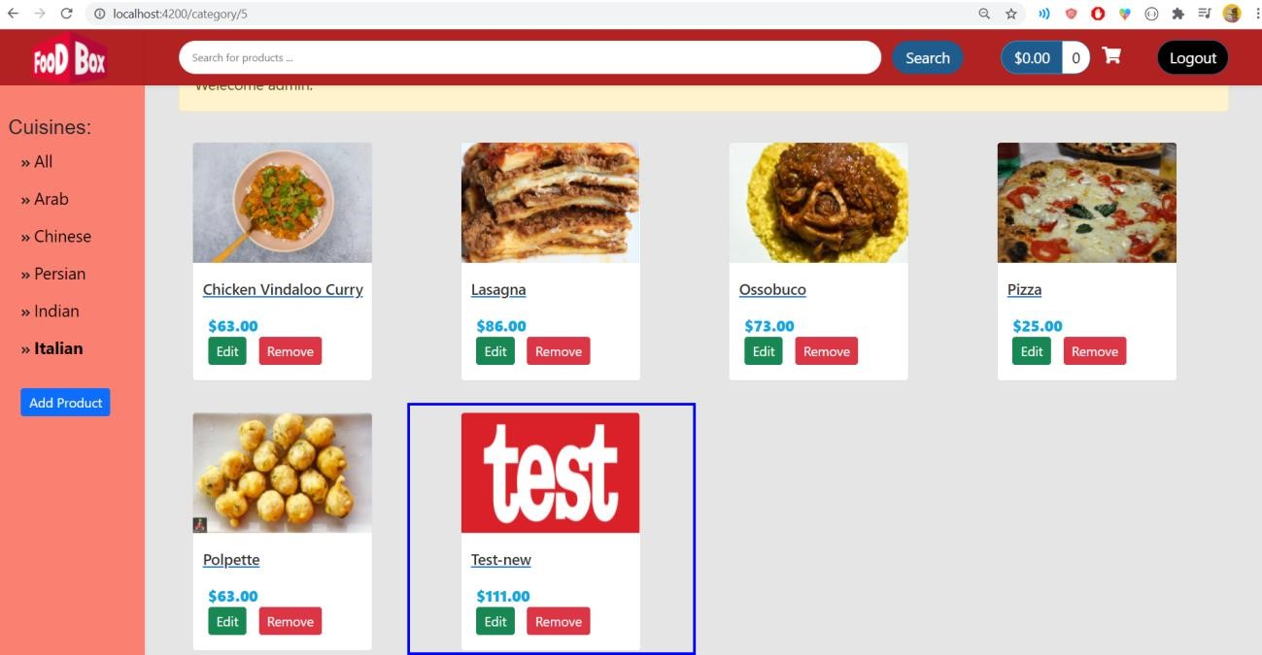

* Click Remove to remove it

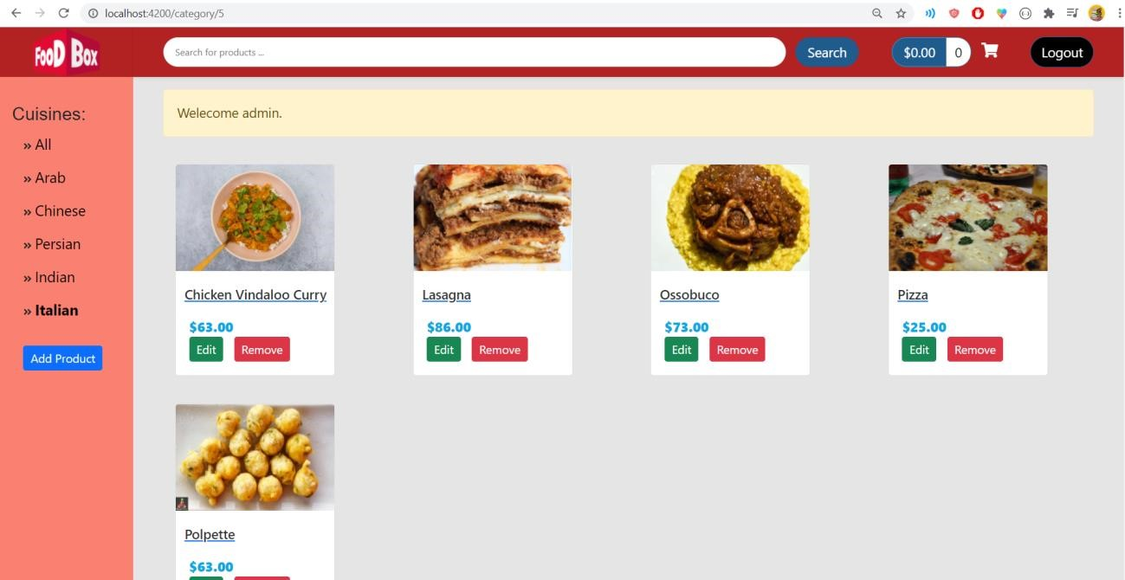

Deployment

